CHAPTER-1
INTRODUCTION
The Road Accident Analysis, addresses the critical issue of road safety in India, where accidents result in significant fatalities and injuries each year. By examining key factors such as population density, gender, safety accessory usage, vehicle types, road conditions, and accident timings over the past years, this analysis aims to uncover trends and insights that can inform effective safety interventions. The project employs machine learning algorithms for accident severity prediction, complemented by interactive visualizations created using Power BI, including graphs, pie charts, and a specific report focusing on the year 2020. Ultimately, this initiative seeks to equip policymakers, road safety authorities, and the public with actionable, data-driven insights to enhance road safety and reduce the incidence of accidents across the country.

  - Problem Statement

Road accidents in India present a serious public safety concern, leading to thousands of fatalities and injuries annually. Despite various safety measures, the increasing frequency of accidents is attributed to factors such as population density, insufficient use of safety accessories, diverse vehicle types, and varying road conditions. Existing data collection methods often lack detailed analysis of these contributing factors. This project aims to analyze road accident data over the past years to identify trends and causes, employing machine learning algorithms for severity prediction and Power BI for interactive visualizations. The insights gained will assist policymakers and road safety authorities in making informed decisions to enhance public safety and reduce accidents.
  - Existing System
Current systems for analyzing road accidents in India predominantly rely on data collection and reporting by government agencies, focusing mainly on aggregated statistics such as total accident counts, fatalities, and injuries. These systems often lack in-depth insights into underlying contributing factors, including population density, gender demographics, safety accessory usage, and road conditions. Furthermore, traditional analysis methods do not leverage advanced analytical tools or machine learning techniques for predicting accident severity, resulting in ineffective risk assessment. Visualization options are typically basic, limiting the understanding of trends and hindering data-driven decision-making. This project aims to address these limitations by employing modern data processing and visualization techniques to provide comprehensive insights into road accident trends and their causes.
  - Proposed System
The proposed system aims to provide a comprehensive analysis of road accident data in India over the past years, focusing on key factors such as population density, gender, safety accessory usage, vehicle types, road conditions, and accident timings. Utilizing machine learning algorithms for accident severity prediction, the system will offer proactive insights into potential risks and identify high-risk areas. Interactive visualizations created in Power BI will include detailed graphs, pie charts, and a dedicated report for 2020, enabling effective exploration of trends and patterns. By addressing the limitations of existing methods, this system will empower policymakers, road safety authorities, and the public to make informed, data-driven decisions aimed at enhancing road safety and reducing accident rates nationwide.
  - Scope
The scope of this project encompasses a detailed analysis of road accident data in India over the past years, focusing on key factors such as population density, gender, safety accessory usage, vehicle types, road conditions, and accident timings. It will utilize machine learning algorithms for predicting accident severity and employ Power BI for interactive visualizations, including trend graphs, pie charts, and a specialized report on 2020 data. The insights generated will assist policymakers, road safety authorities, and the public in making informed, data-driven decisions aimed at enhancing road safety and reducing accident rates, while also promoting public awareness of critical safety issues.
CHAPTER-2
SYSTEM REQUIREMENTS SPECIFICATIONS
2.1 Software Requirements
- HTML/CSS for structuring and styling web pages.
- Flask, a Python web framework, for server-side logic and routing.
- Operating System: Windows for development environment.
- Power BI for data visualization and dashboard creation.
2.1.1 Functional Requirements
Data Collection and Processing:
- Ability to import and preprocess road accident data from various sources( Excel).
- Implementation of data cleaning and transformation techniques to ensure data quality.
Web Application Development:
- Use of Flask to create a web application that serves as the interface for users to interact with the system.
Accident Severity Prediction:
- Integration of machine learning algorithms (e.g.,decision trees, random forests) to predict the severity of road accidents based on identified factors.
- Model training and evaluation to ensure accuracy and reliability of predictions.
Data Visualization:
- Development of interactive dashboards using Power BI, including:
  - Graphs depicting accident trends over time.
  - Pie charts illustrating the distribution of accidents by various factors (e.g., vehicle type, gender).
  - A detailed report focused on the year 2020, providing specific insights and analyses.
2.1.2 Non-Functional Requirements
Performance:
- The system should process and analyze data efficiently, providing results in a timely manner.
Scalability:
- Ability to accommodate additional data sources or increased data volume without significant performance degradation.
Usability:
- The user interface should be intuitive and user-friendly, allowing stakeholders to easily navigate and interpret the visualizations.
Reliability:
- The system should be robust, ensuring accurate predictions and maintaining data integrity.
2.2 Hardware Requirements
Processor: Intel Pentium 4 or equivalent,1 GHz or higher
RAM : 4GB or higher

2.3 Block Diagram
This block diagram outlines the stages of a road accident analysis project, from data collection to output generation. It begins with gathering and preprocessing data, followed by analysis and machine learning modeling. The results are then visualized and presented through a user interface to produce the final output.
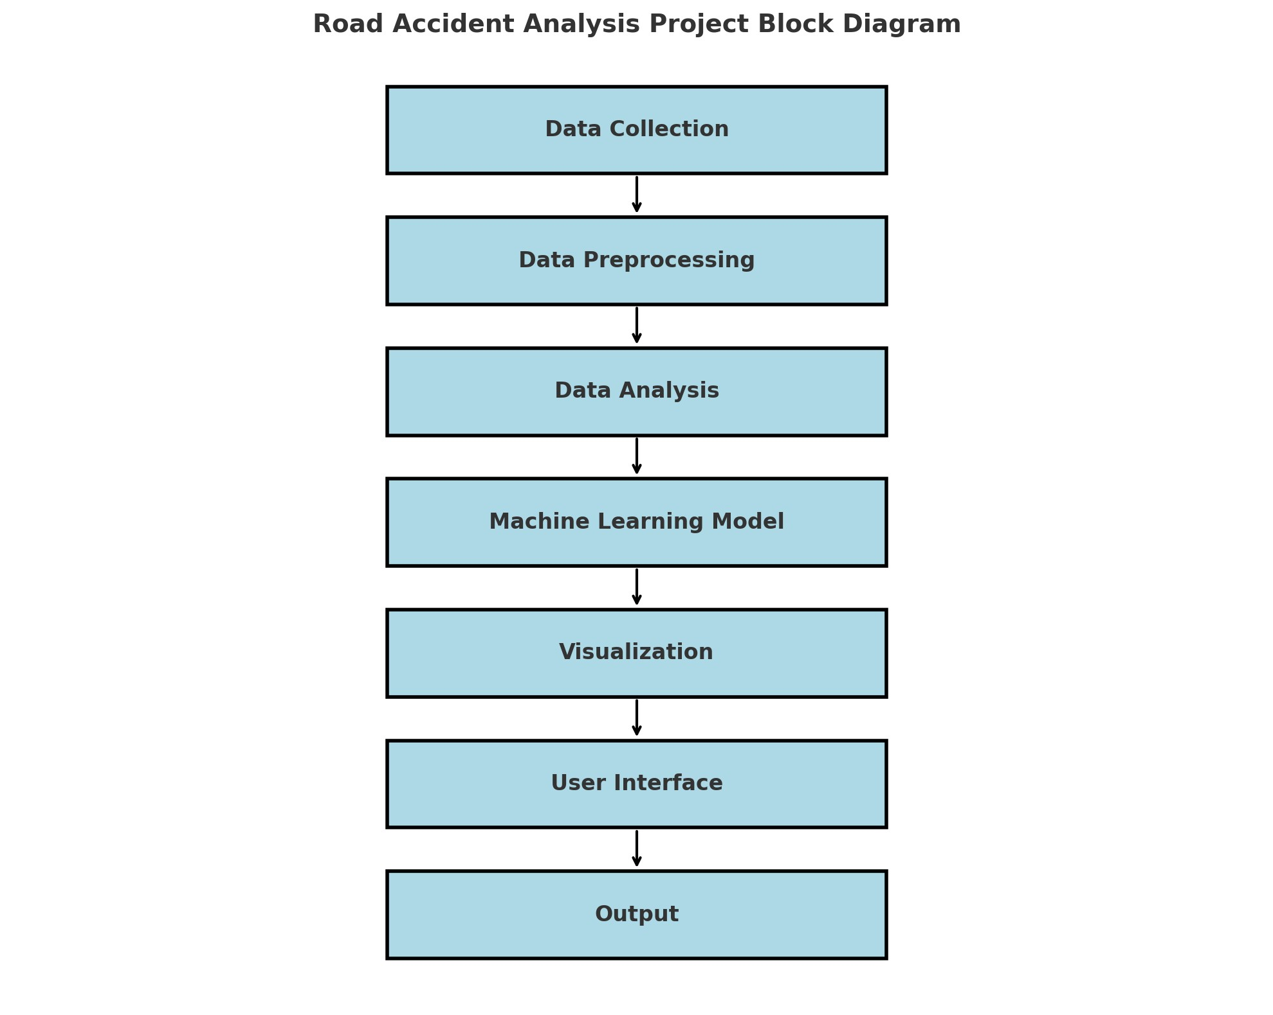
Fig 2.3.1: Block Diagram

CHAPTER-3
SYSTEM DESIGN
3.1 Methodology
Data Acquisition
- Data Sources: Collect data from government databases, traffic police reports, public health records, and possibly third-party APIs.
- Data Storage: Use a database (e.g., PostgreSQL, MySQL) to store historical data on accidents, population density, vehicle types, etc.
Data Processing
- ETL Process: Implement an ETL (Extract, Transform, Load) pipeline to clean and prepare the data for analysis.
  - Extract: Pull data from various sources.
  - Transform: Clean the data (remove duplicates, handle missing values, etc.) and format it for analysis.
  - Load: Store the processed data in the database.
- Python Scripts: Write Python scripts to automate data processing and analysis tasks using libraries such as Pandas and NumPy.
Machine Learning
- Model Selection: Choose appropriate machine learning algorithms for accident severity prediction (e.g., decision trees, random forests).
- Training and Evaluation: Split the data into training and testing sets, train the models, and evaluate their performance using metrics like accuracy, precision, recall, and F1-score.
- Model Deployment: Deploy the trained model as a RESTful API using Flask, allowing the web application to access it for predictions.

Web Application Development
- Framework: Use Flask to build a web application that serves as the user interface.
- User Interface: Design a user-friendly interface that allows users to:
  - View accident analysis graphs and pie charts.
  - Access the accident severity prediction feature.
  - View the 2020-specific analysis report.
- API Integration: Integrate the machine learning model API for real-time predictions within the application.
Data Visualization
- Power BI Integration: Utilize Power BI to create interactive dashboards and visualizations based on the processed data.
  - Graphs and Charts: Generate visual representations of trends and insights from the data.
  - User Interaction: Enable users to interact with the dashboards to filter data by year, region, vehicle type, etc.
3.1.1 Dataset Description
The dataset for the Road Accident Analysis project is structured to support both prediction and analysis of road accidents in India. It consists of two main components: a predictive dataset and an analytical dataset.
1. Predictive Dataset
This dataset is used for predicting accident severity and includes the following key attributes:
- Sex of the Driver: Gender of the driver involved in the accident (male/female).
- Vehicle Type: Type of vehicle involved (e.g., two-wheeler, car, truck).
- Speed Limit: Speed limit of the road where the accident occurred (in km/h).
- Road Type: Classification of the road (e.g., highway, city road, rural road).
- Number of Passengers: Total number of passengers in the vehicle.
- Day: Day of the week when the accident occurred (e.g., Monday, Tuesday).
- Light Conditions: Lighting conditions at the time of the accident (e.g., daylight, nighttime, dusk).
2. Analytical Dataset
This dataset focuses on analysis based on yearly data and includes:
- Year: The year of the accident.
- Deaths: Number of fatalities resulting from accidents in that year.
- Injuries: Number of injuries recorded in accidents.
- Cases: Total number of reported accident cases.
- Reasons for Accidents: Categorized reasons contributing to accidents (e.g., speeding, drunk driving, distracted driving).
3.1.2 Algorithms Description
In the Road Accident Analysis project, we employ two primary machine learning algorithms for predicting accident severity: the Decision Tree Classifier and the Random Forest Classifier. Below is a brief description of each algorithm:
1. Decision Tree Classifier
- Overview: The Decision Tree Classifier is a supervised learning algorithm that constructs a model in the form of a tree-like structure. Each internal node of the tree represents a decision based on the value of an input feature, and each branch represents the outcome of that decision. The leaf nodes of the tree indicate the final prediction or outcome.
- Characteristics:
  - Interpretability: The decision tree provides a clear and interpretable model, allowing users to understand the decision-making process.
  - Handling Non-Linearity: It can effectively capture non-linear relationships between features and the target variable.
  - Feature Importance: The algorithm inherently provides information on the importance of each feature in making predictions, which can help identify significant factors influencing accident severity.
- Use Case: It is particularly useful for scenarios where interpretability is essential, such as identifying factors leading to severe accidents.
2. Random Forest Classifier
- Overview: The Random Forest Classifier is an ensemble learning method that builds multiple decision trees and combines their predictions to enhance overall predictive accuracy and robustness. Each tree is trained on a random subset of the data, and predictions are made by aggregating the results (typically through majority voting for classification tasks).
- Characteristics:
  - Improved Accuracy: By averaging the predictions of multiple trees, the Random Forest reduces the risk of overfitting that can occur with individual decision trees, leading to better generalization on unseen data.
  - Robustness: It is less sensitive to noise and outliers compared to single decision trees, making it more reliable in real-world applications.
  - Feature Importance: Like decision trees, Random Forest also provides insights into feature importance, aiding in understanding the drivers behind accident severity.
- Use Case: This algorithm is ideal for large datasets with complex interactions among features, offering strong predictive performance for accident severity predictions.

3.2 Structural Diagram
1.Class Diagram
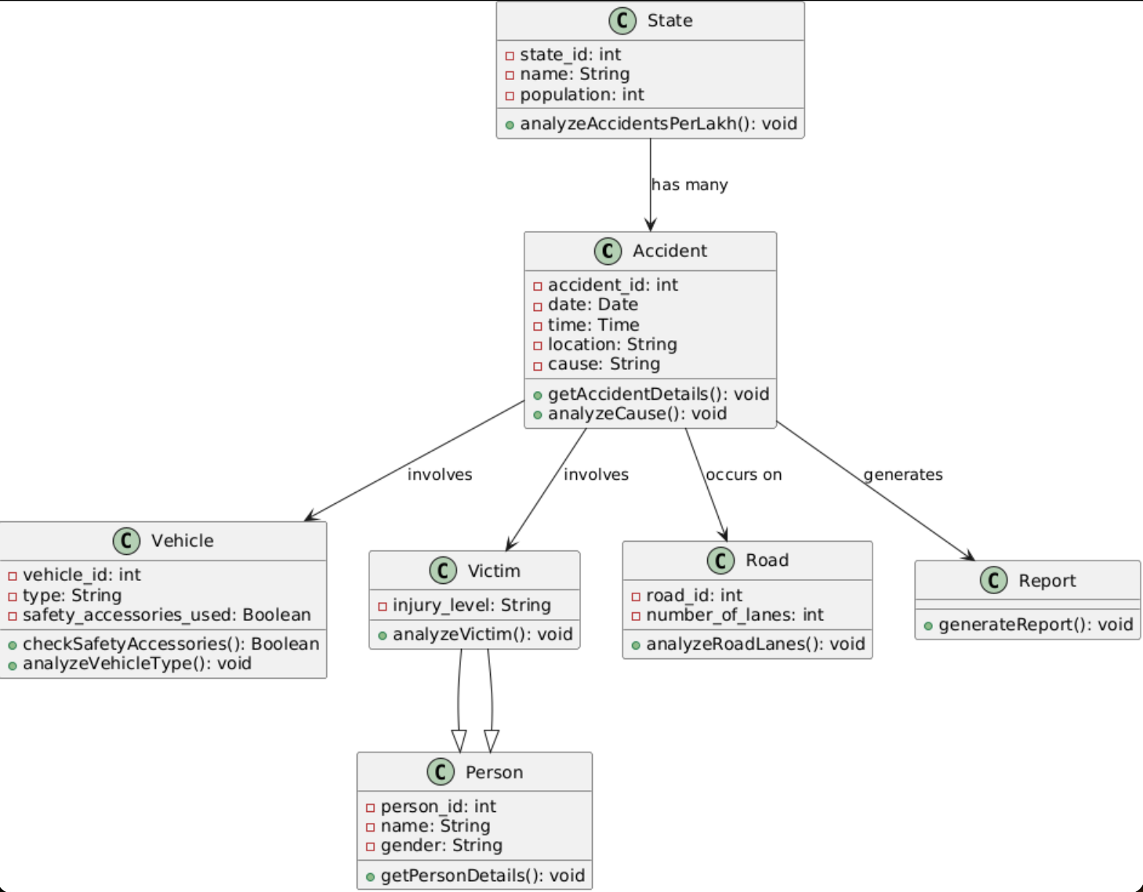
Fig 3.2. 1: Class Diagram

3.3 Behavioural Diagrams
1.Sequence Diagram
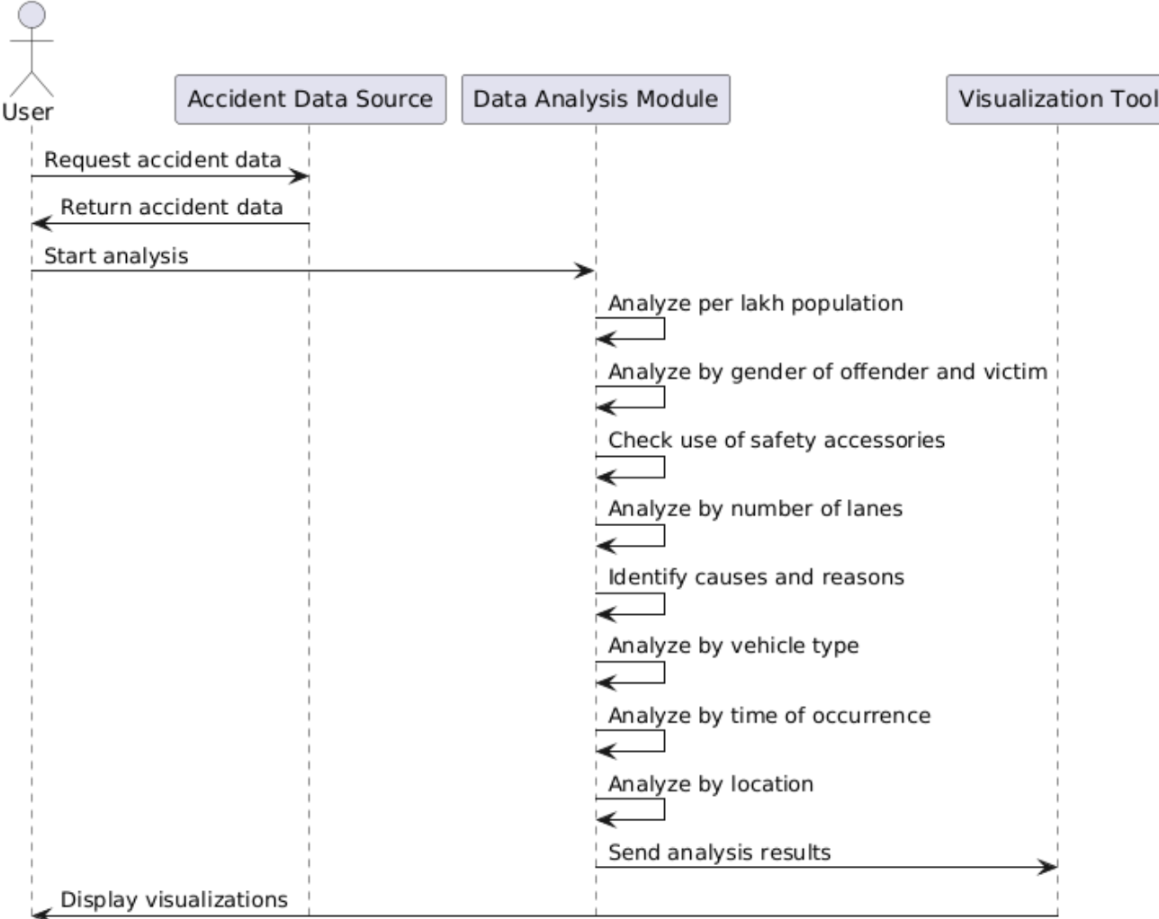
Fig 3.3.1: Sequence Diagram

2.Use Case Diagram
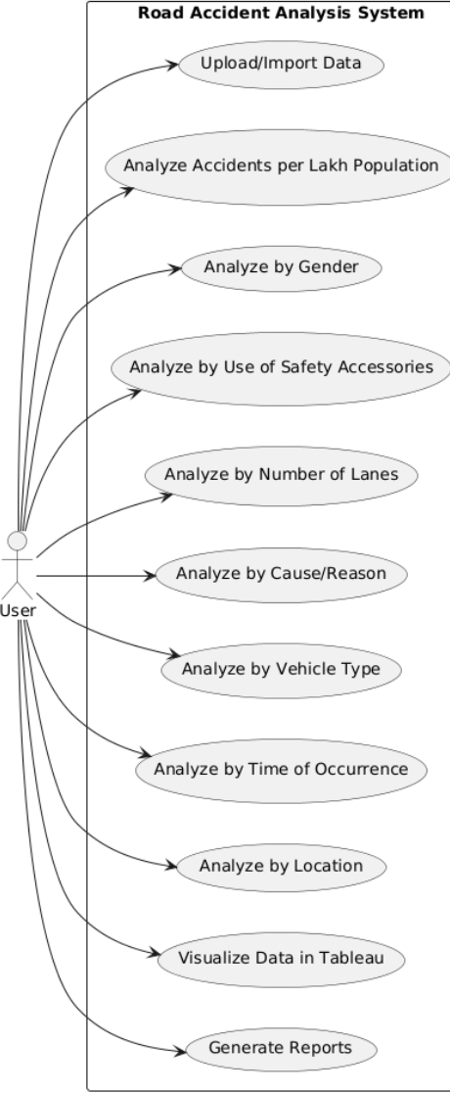
Fig 3.3.2: Use case Diagram

CHAPTER-4
RESULTS & DISCUSSION
4.1 Environmental Setup
Prerequisites
- Python: Ensure you have Python 3.6 or later installed on your system.
- pip: Make sure you have the Python package installer (pip) installed.
- Virtual Environment: It's recommended to use a virtual environment to manage project dependencies.
Step-by-Step Setup
1. Install Python and pip
- Download and install Python from the official Python website.
- Ensure that the installation includes pip, which is typically included with Python installations.
2. Create a Virtual Environment
- If virtualenv is not already installed, you can install it using pip:
pip install virtualenv
- Create and activate a virtual environment:
On Windows:
python -m venv road_accident_env
road_accident_env\Scripts\activate
3. Install Required Python Packages
- Create a requirements.txt file in your project directory to list all necessary Python packages:
pandas
numpy
matplotlib
seaborn
scikit-learn
imbalanced-learn
flask
Use the following command to install all the dependencies listed in the requirements.txt file:
pip install -r requirements.txt
4. Set Up the Flask Application
- Create a project directory (e.g., road_accident_analysis).
- Within this directory, create subdirectories for templates and static files:
road_accident_analysis/
├── templates/
├── static/
- Create a main application file (e.g., app.py) to define the Flask application and its routes.
5. Prepare the Machine Learning Model
- Train your machine learning models (e.g., Decision Tree, Random Forest) using the road accident dataset.
- Save the trained model as a serialized file using Python's pickle module:
import pickle
with open('model.pkl', 'wb') as file:
pickle.dump(model, file)
6. Create HTML Templates
- In the templates directory, create an HTML file (e.g., index.html) to build the user interface. This file should include a form for inputting relevant data and displaying prediction results.
7. Run the Flask Application
- Run your Flask application locally to test the setup and ensure everything is working correctly:
python app.py
- Access the application through a web browser at http://127.0.0.1:5000/.

4.2 Implementation Details
The implementation of the Road Accident Analysis project involves several key components, including data preprocessing, model training, web application development, and deployment. Below are the details of each stage of the implementation process:
1. Data Preprocessing
- Loading the Dataset: The dataset (accidents_india.csv) is loaded using the pandas library, enabling efficient data manipulation and analysis.
- Handling Missing Values: The dataset is examined for missing values, which are filled or removed based on the significance of the feature and its impact on the analysis.
- Feature Encoding: Categorical variables, such as Accident_Severity, Day_of_Week, and Light_Conditions, are converted into numerical format using LabelEncoder to facilitate model training.
- Feature Selection: Irrelevant or redundant features are dropped to enhance model performance. The final feature set includes the variables necessary for predicting accident severity.
2. Model Training
- Data Splitting: The dataset is split into training and testing sets using train_test_split from scikit-learn, with an 80-20 split to evaluate model performance on unseen data.
- Handling Class Imbalance: The Synthetic Minority Over-sampling Technique (SMOTE) is applied to address class imbalance in the target variable (accident severity), ensuring better model training.
- Model Implementation:
  - Decision Tree Classifier: A Decision Tree model is instantiated and trained using the training data.
  - Random Forest Classifier: An ensemble of decision trees (Random Forest) is also trained on the same data for improved accuracy and robustness.
- Model Evaluation: The models are evaluated using metrics such as accuracy, precision, recall, and F1-score. A confusion matrix is generated to visualize the performance of the Random Forest model.
3. Web Application Development
- Framework: Flask is chosen as the web framework due to its simplicity and flexibility in creating web applications.
- Application Structure: The project directory is organized with clear separation of concerns:
  - templates/: Contains HTML files for the user interface.
  - static/: Holds static files like CSS and JavaScript.
  - app.py: The main application file containing routes and logic for handling user requests and displaying results.
- User Interface: HTML forms are created in index.html to allow users to input data for predictions. The application captures user input and feeds it into the trained models to generate predictions.
4. Model Deployment
- The Flask application is tested locally to ensure all components are functioning correctly.
- Once verified, the application can be deployed on a web server (e.g., Heroku, AWS, or any cloud service provider) to make it accessible to users for real-time analysis and predictions.
5. Visualization and Reporting
- Visualizations are created using matplotlib and seaborn to present analysis results effectively. Graphs and pie charts display trends and statistics related to road accidents over the years.
- A comprehensive report is generated, summarizing the findings of the analysis and predictions, which can be shared with stakeholders and policymakers to inform road safety initiatives.

4.3 Results
1.prediction page
The prediction page allows users to estimate accident severity based on key factors such as driver demographics, vehicle type, and road conditions.
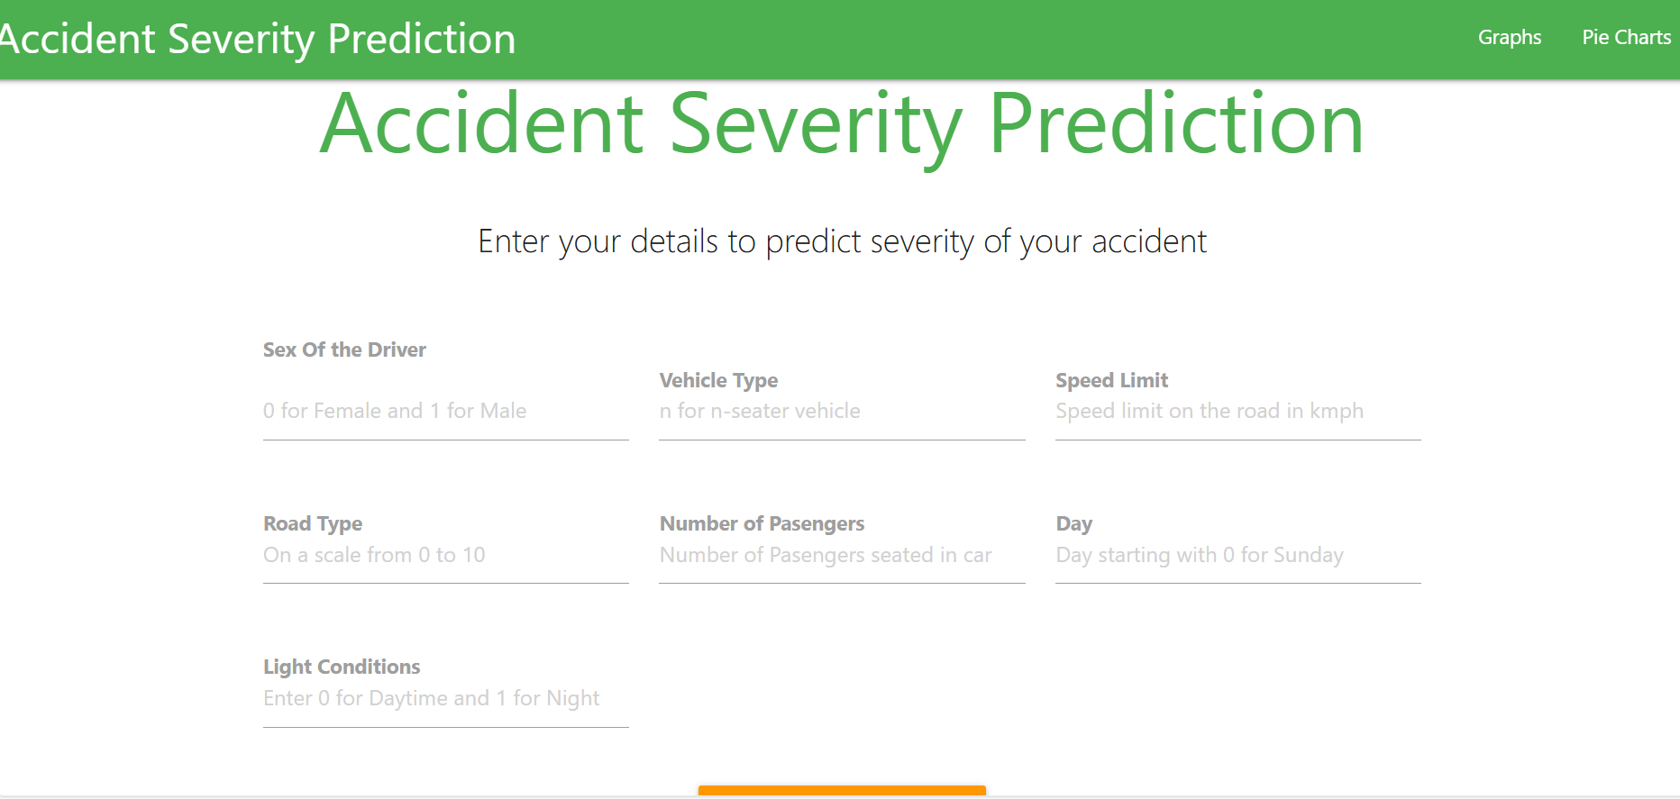
Fig 4.3.1: Prediction Page
2. Graphical Overview of Road Accident StatisticsThe graphical overview provides visual insights into road accident statistics, highlighting trends and patterns across various factors and timeframes. 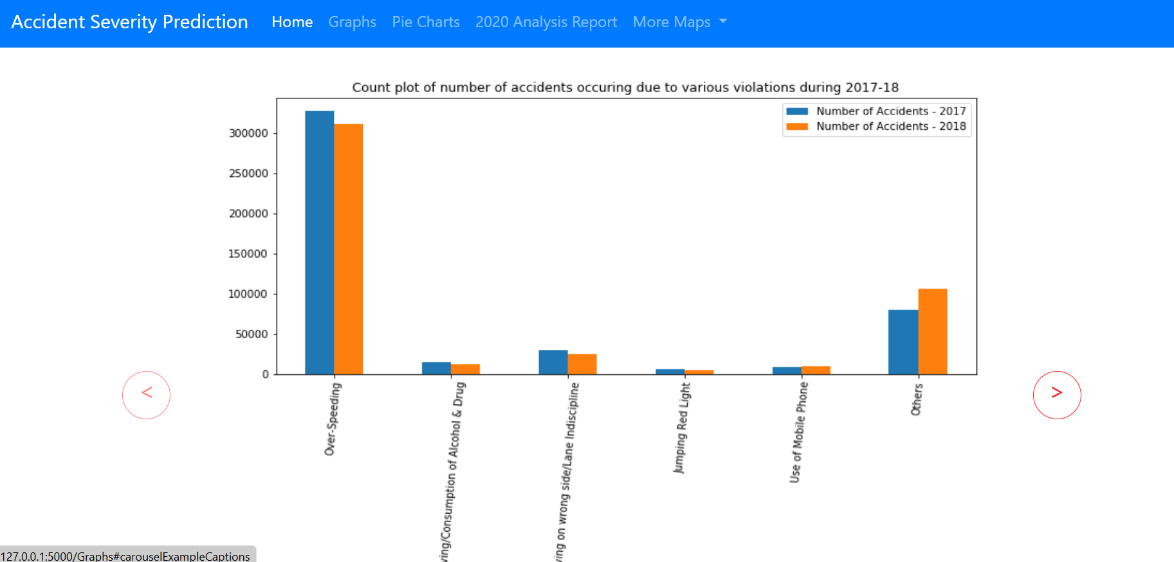
Fig 4.3.2: Visual Graphs Page
3.Pie charts Overview of Road Accident Statistics
The pie charts overview visually represents the distribution of road accident statistics, showcasing the proportions of different contributing factors and outcomes for easy comparison and analysis.
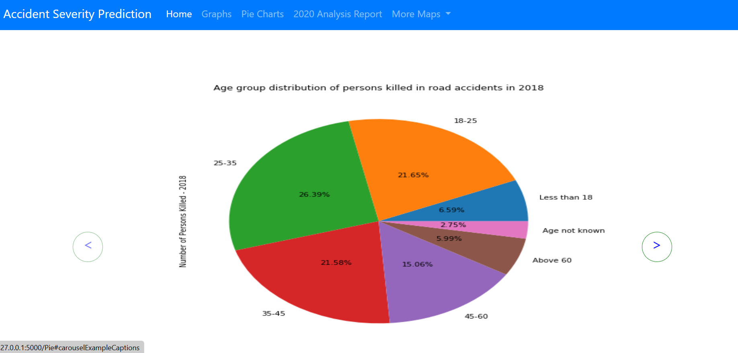
Fig 4.3.3: Visual Pie charts Page
- 2020 Analysis Report
The 2020 Analysis Report offers a detailed examination of road accident statistics for the year, highlighting key trends, causes, and outcomes to inform safety measures and policy decisions.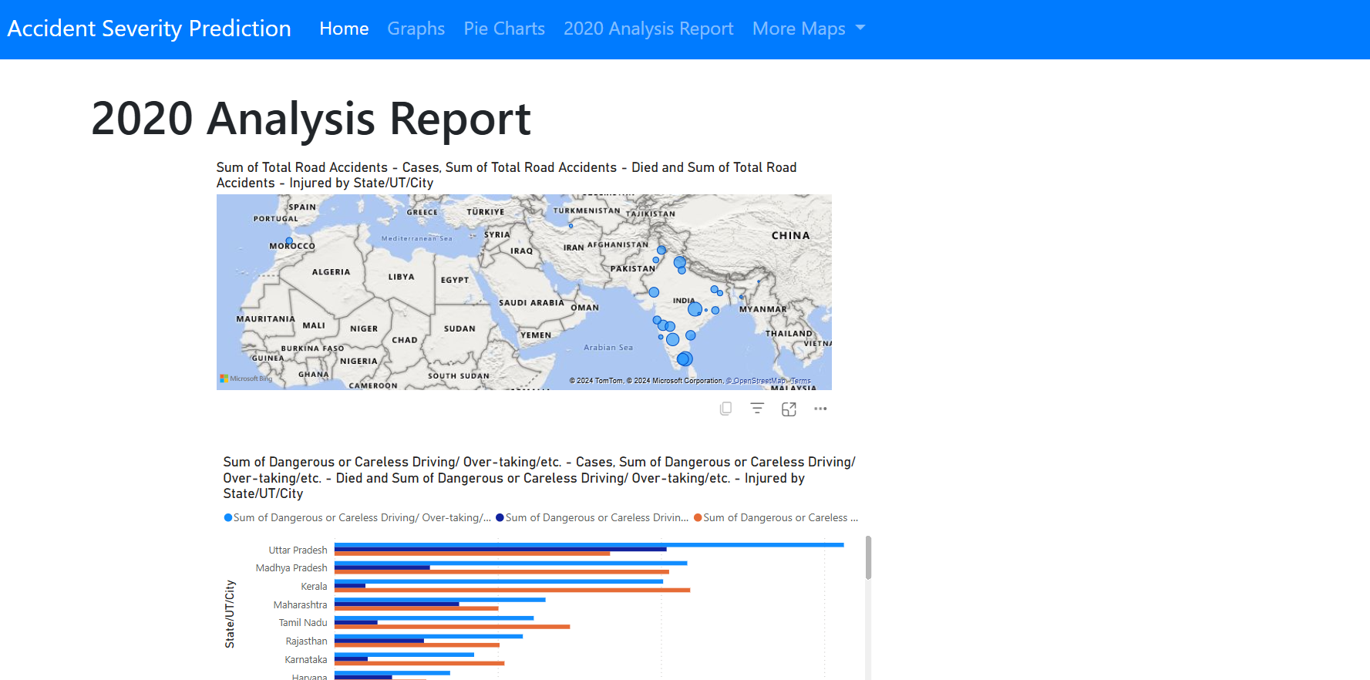
Fig 4.3.4: Analysis Report Page
4.4 Test cases
Test Case No | Test Case Name | Test Case Input | Test Case Output | Test Case Status (Pass/Fail)
1 | Validate Input Data Format | Valid inputs: Male, Car, 60 km/h, Highway, 2 passengers, Monday, Daylight | Model accepts inputs without errors. | Pass
2 | Predict Severity for Known Data | Historical data with known outcomes | Model predicts severity correctly based on input attributes. | Pass
3 | Verify Pie Chart Data Accuracy | Accident data for pie chart segments | Each pie chart segment corresponds to the correct percentage of total accidents. | Pass
4 | Ensure Graphs Render Correctly | Graphs displaying accident statistics | All graphs display without errors and represent intended data clearly. | Pass

CHAPTER-5
CONCLUSION & FUTURE ENHANCEMENTS

Conclusion
The Road Accident Analysis project analyzes road safety issues in India by using data analytics and machine learning to reveal accident trends and severity patterns. It examines factors like population density, vehicle types, driver demographics, and road conditions to identify causes of accidents. A predictive model assesses accident severity based on real-time data, helping stakeholders implement targeted safety measures. Interactive visualizations enhance decision-making for policymakers and the public, providing actionable insights to reduce accidents and improve traffic management. This project highlights the importance of ongoing road safety data analysis and monitoring.

Future Enhancements
Future enhancements to the Road Accident Analysis project could greatly increase its impact. Integrating real-time data from traffic cameras and sensors will enable proactive safety measures, while adding weather data will offer a clearer view of environmental effects on accidents. GIS tools could identify accident hotspots for targeted interventions. A user feedback mechanism and partnerships with local authorities for awareness campaigns will encourage continuous improvement and public education. Developing a mobile app for safety alerts and resources will make road safety information more accessible. These enhancements will strengthen the project’s potential to reduce accidents and improve road safety.

source/pseudo code
from flask import Flask, request, render_template, url_for
import numpy as np
import pandas as pd
from sklearn.model_selection import train_test_split
from sklearn.tree import DecisionTreeClassifier

app = Flask(__name__)

# Load and prepare data
df = pd.read_csv('accidents_india.csv')
df.dropna(inplace=True)
df['Day'] = df['Day_of_Week'].astype('category').cat.codes
df['Light'] = df['Light_Conditions'].astype('category').cat.codes
df['Severity'] = df['Accident_Severity'].astype('category').cat.codes
df.drop(['Day_of_Week', 'Light_Conditions', 'Accident_Severity'], axis=1, inplace=True)

x = df.drop(['Pedestrian_Crossing', 'Special_Conditions_at_Site', 'Severity'], axis=1)
y = df['Severity']
x_train, x_test, y_train, y_test = train_test_split(x, y, test_size=0.86)
model = DecisionTreeClassifier(criterion='gini')
model.fit(x_train, y_train)

@app.route('/')
def hello_world():
return render_template("t.html")

@app.route('/predict', methods=['POST', 'GET'])
def predict():
try:
int_features = [int(x) for x in request.form.values()]
final = [np.array(int_features)]
prediction = model.predict(final)

if prediction == 0:
return render_template('t.html', pred="Probability of accident severity is: Minor")
else:
return render_template('t.html', pred="Probability of accident severity is: Major")

except Exception as e:
return render_template('t.html', pred="Error: " + str(e))

@app.route('/Map')
def map1():
return render_template("map.html")

@app.route('/Graphs')
def graph():
return render_template("graph.html")

@app.route('/Pie')
def pie():
return render_template("pie.html")

@app.route('/Map1')
def map2():
return render_template("ur.html")

@app.route('/Map2')
def map3():
return render_template("bs.html")

@app.route('/Map3')
def map4():
return render_template("hm.html")

@app.route('/2020_analysis_report')
def powerbi_report():
return render_template('2020_analysis_report.html')

if __name__ == "__main__":
app.run(debug=True)

